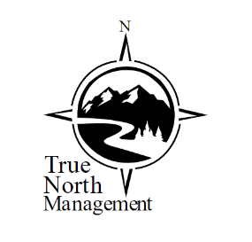

True North Management Pre-Screening Rental Criteria

All applicants over the age of 18 need to complete an application on Zillow. Here are the standard criteria for all applicants and properties with True North Management, LLC.

- No misdemeanors
- No felonies
- No open bankruptcy
- No evictions
- No moneys owned to another landlord or previous rental
- Income two times the rental amount, gross
- No smoking on-site
- Two months of income documentation
- Two years rental history verified

